Результат эксперимента: Кодер betago он же семиплановый. Сеть large, оптимизатор adadelta. Количество игр 1000. Batchsize 128.

...
1447/1448 [============================>.] - ETA: 0s - loss: 0.0531 - accuracy: 0.9852
1448/1448 [==============================] - 69s 48ms/step - loss: 0.0531 - accuracy: 0.9852 - val_loss: 0.0402 - val_accuracy: 0.9852
Restoring model weights from the end of the best epoch
Epoch 00046: early stopping
Test score: 0.040201082825660706
Test accuracy: 0.9852112531661987

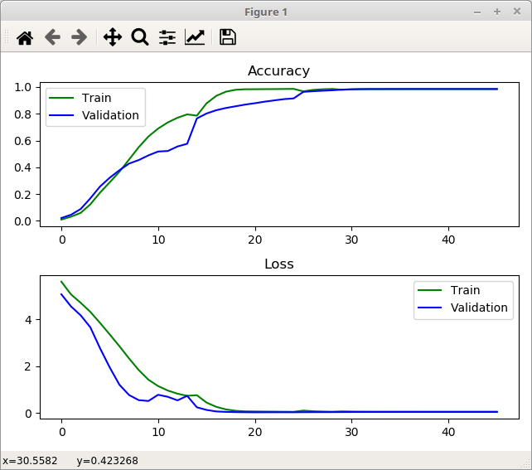

Количество игр 1500. Остальные параметры как и ранее:
...
2212/2216 [============================>.] - ETA: 0s - loss: 0.0432 - accuracy: 0.9866
2214/2216 [============================>.] - ETA: 0s - loss: 0.0432 - accuracy: 0.9867
2216/2216 [==============================] - 134s 60ms/step - loss: 0.0432 - accuracy: 0.9867 - val_loss: 0.0033 - val_accuracy: 0.9867
Restoring model weights from the end of the best epoch
Epoch 00053: early stopping
Test score: 0.00335422670468688
Test accuracy: 0.9866595268249512
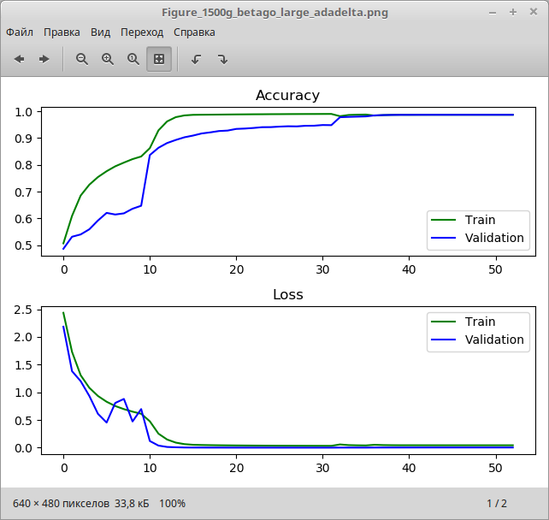
Количество игр 2000:
…

2973/2976 [============================>.] - ETA: 0s - loss: 0.0583 - accuracy: 0.9827
2975/2976 [============================>.] - ETA: 0s - loss: 0.0583 - accuracy: 0.9827
2976/2976 [==============================] - 160s 54ms/step - loss: 0.0583 - accuracy: 0.9827 - val_loss: 0.0883 - val_accuracy: 0.9827
Restoring model weights from the end of the best epoch
Epoch 00056: early stopping
Test score: 0.08825747668743134
Test accuracy: 0.9827211499214172
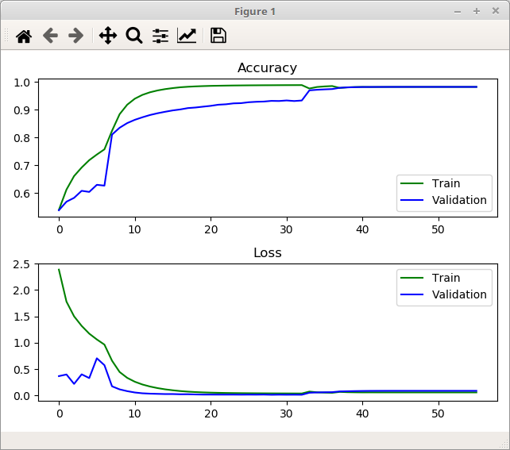
2500 игр:

...
3709/3712 [============================>.] - ETA: 0s - loss: 0.0963 - accuracy: 0.9697
3711/3712 [============================>.] - ETA: 0s - loss: 0.0963 - accuracy: 0.9698
3712/3712 [==============================] - 204s 55ms/step - loss: 0.0963 - accuracy: 0.9698 - val_loss: 0.1155 - val_accuracy: 0.9698
Restoring model weights from the end of the best epoch
Epoch 00064: early stopping
Test score: 0.11545772105455399

